Tutorial 2

Chapter 2

- Discuss why knowledge acquisition is a difficult process.
Knowledge acquisition is a difficult process because:
- Distributed sources, conflict viewpoints
- Difficult access to key people and data
- Different background, terminology, culture
- Hidden needs, irrelevant details
- Internal politics, competition, resistance to change
- Personnel turnover, changes in organisation

- Explain Scenarios artefact-driven requirement elicitation technique. Discuss the pros and cons.
Scenarios artefact-driven requirement elicitation technique. Discuss the pros and cons.
Illustrate typical sequences of interaction among system components to meet an implicit objective
Widely used for...
explanation of system-as-is
exploration of system-to-be + elicitation of further info ...
e.g. WHY this interaction sequence ?
WHY among these components ?
specification of acceptance test cases
Represented by text or diagram

-Positive scenario = one behavior the system should cover (example)
- Negative scenario = one behavior the system should exclude (counter-example), e.g.
1. A participant returns a list of constraints covering all dates within the given date range
2. The scheduler forwards this message to all participants asking them for alternative constraints within extended date range
- Normal scenario: everything proceeds as expected
- Abnormal scenario = a desired interaction sequence in exception situation (still positive)
e.g. meeting initiator not authorized
participant constraints not valid
Pros:
-Concrete examples/counter-examples
-Narrative style (appealing to stakeholders)
-Yield animation sequences, acceptance test cases
Cons:
- Inherently partial (-test coverage problem)
- Potential over specification: unnecessary sequencing, premature software-environment boundary
- May contain irrelevant details, incompatible granularities from different stakeholders

3. Assume that you are going to adopt Knowledge Reuse requirements elicitation technique for an upcoming project to develop a library system. With the aid of a diagram and example, discuss Reuse of Domain-Independent Knowledge technique.
Reused domain meta model = concept and relationship in term of which are item are capture
Elicitation by meta model troublesome
Are the items are acquired as instantiations of meta model items
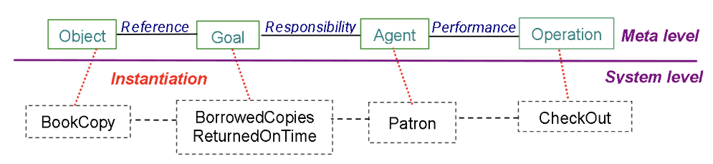

- Assume that you have been assigned to lead a project team of 15 software engineers to develop an Online Hotel Room Reservation System for STAR Hotel. This is the first time your team ventures into this area. The management of the hotel wanted the new system to be ready in 6 months. Furthermore, after the initial requirements gathering exercise, you found that the top management of the client was very supportive of the upcoming project. However, the lower management and staff were not cooperative and showed resistance to the new system.

- Explain TWO (2) criteria you would use for stakeholder analysis.
- Relevant position in the organization
- Roles in making decisions, reaching agreement
- Types of contribution knowledge, level of domain expertise
- Exposure to perceived problem
- Personal interest , potential conflict

- State and explain THREE (3) stakeholders for the above mentioned system.
Online customer, trading company sales manager, sales clerk

- Suggest and explain FOUR (4) requirements elicitation techniques that your team would adopt for the project. Justify your suggestions. You may state any relevant assumptions to support your answer.

Background study , observation , interview, knowledge reuse

- As a senior software engineer, discuss FIVE (5) guidelines for an effective interview to your juniors.
Identifies the right interviewee
For full coverage of issues
Centered the interview on the interviewee work and concerns
Keep control on the interview
Make the interviewee feel comfortable
Be focus , keep open ended questions for the end
Edit and structure interview transcripts

- Differentiate Active observation from Passive observation.
Passive - No interference with task performance
- Walk from outside, record [notes, video, edit transcript, interpret]
Active - u get involved in the task, even become a team member

7. With the aid of a diagram, discuss the activities involved in the Requirements Elicitation Process.
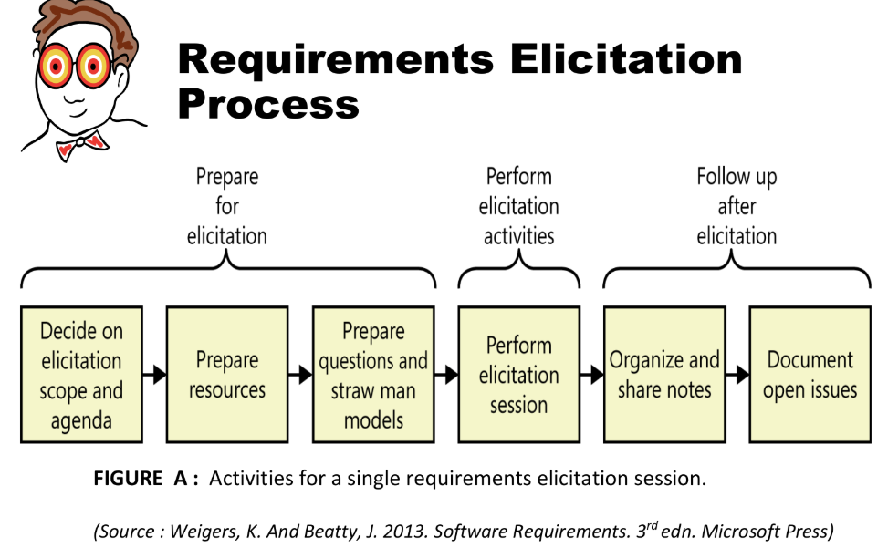
Preparing for elicitation
i)Plan on the scope and agenda
Decide on scope, align the scope of elicitation with overall project scope
itemize the agenda in topics
Taking account the available time
ii)Prepare resources
Identify relevant stakeholders and learn about them
Schedule physical resources (room, equipment etc), participants, collect various documents, learn about existing system etc
iii) Prepare questions and straw man model
Prepare a set of relevant questions
Ask different type of question for different situation, eg: open-ended question to help understand current system process and to see how the new system could improve the performance
Analysis models can be used to help provide better requirements
Some of the useful models are use case model, activity diagram etc
Create straw man models or draft models ahead of your elicitation sessions
Straw man model serves as a starting point that helps you learn about the topic

Performing elicitation
-Executing the elicitation activity : interview, observation, documentation reviews etc
-Useful tips for performing elicitation:
Educate stakeholders
Take good notes
Exploit the physical space
Following up after elicitation
i) Organizing and sharing the notes
Consolidate the inputs from multiples sources through various elicitation techniques
Keep a set of raw notes to refer later if necessary after editing the notes
Share the notes to participants for reviewing
Share the notes with other stakeholders to flag any issues
ii) Document open issues
Items that need to be further explored, knowledge gap that you need to close, new questions while reviewing your notes etc
Record them in a issue-tracking tool - to record the relevant notes, progress already made, owner, due date etc

